**Handling Traffic with Ingress Controller**

* **Load Balancer Services:**

**Note:** In this tutorial we are not going to use Load Balancer service.

Load Balancer gives access to one set of pods.

* **A Quick Note on Ingresses:**

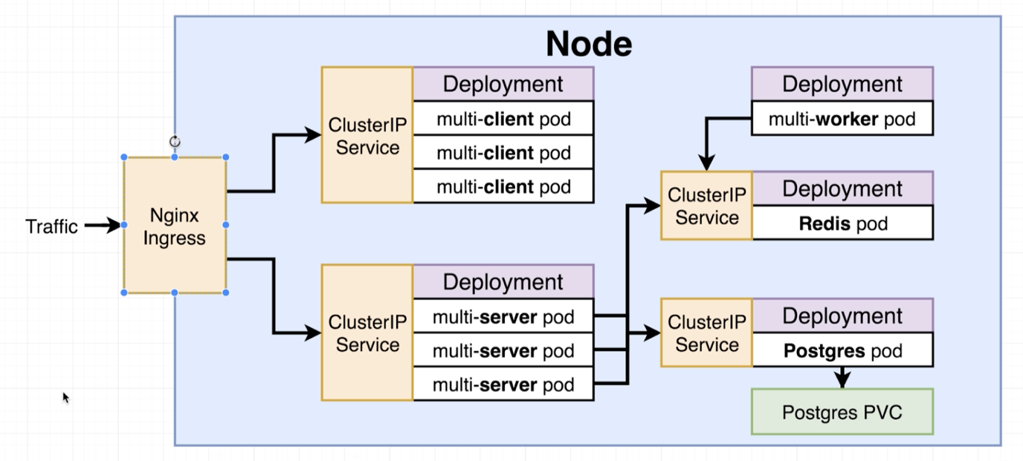

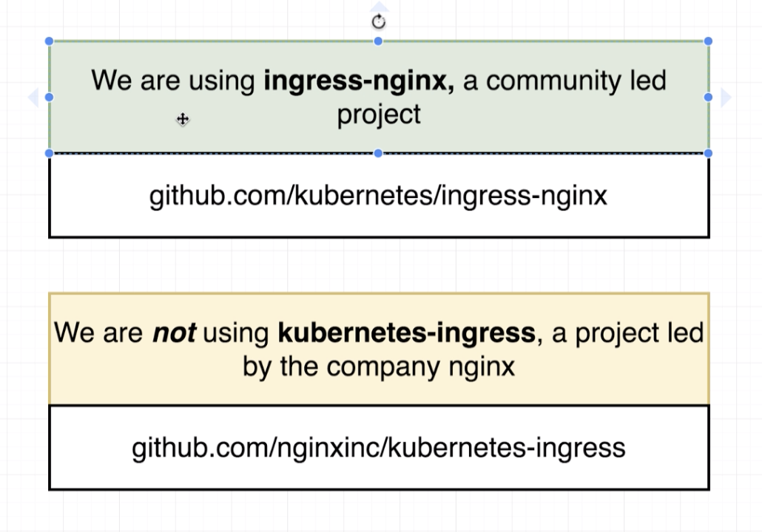

* **One Other Quick Note:**

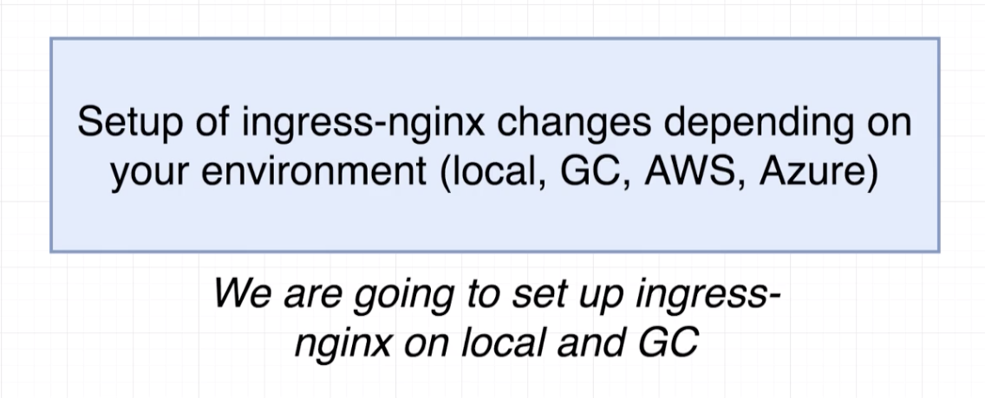

* **Behind the Scenes of Ingress:**

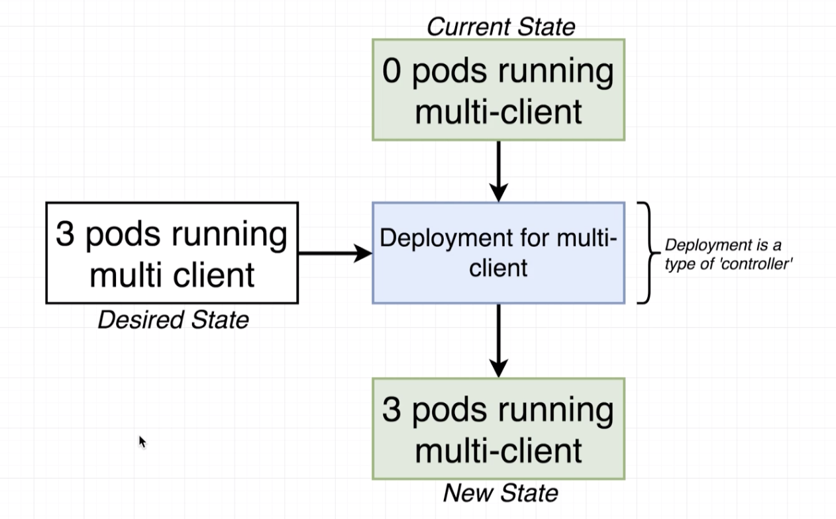

* **More Behind the Scenes of Ingress:**

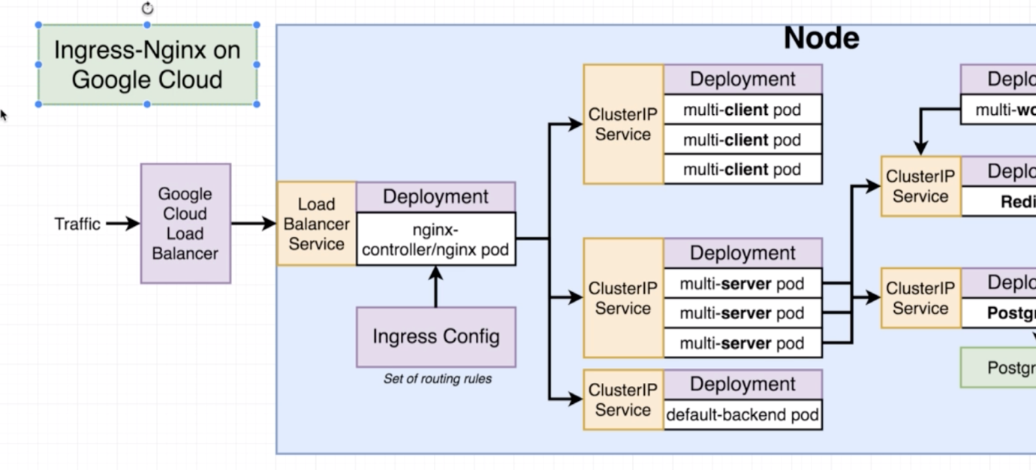

Default backend is used to do the health check.

Directly accessing the pod is used in case of sticky sessions. When the same user tries to access an application with two different client.

To read more about ingress-nginx:

<https://www.joyfulbikeshedding.com/blog/2018-03-26-studying-the-kubernetes-ingress-system.html>.

* **Setting up Ingress Locally:**

Go to this page: <https://github.com/kubernetes/ingress-nginx>

Click link: <https://kubernetes.github.io/ingress-nginx/>

In resulting page find the page named with ”Provider specific steps”

<https://kubernetes.github.io/ingress-nginx/deploy/#provider-specific-steps>

And run the commands which are named: “Docker for Mac” and “minikube”

* **Creating the Ingress Configuration:**

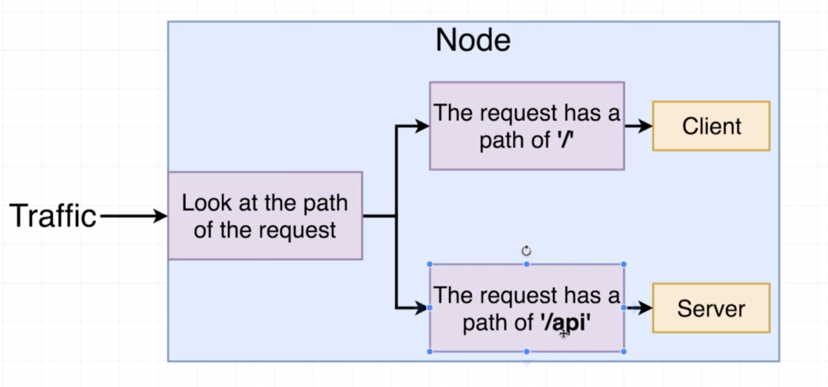

apiVersion: extensions/v1beta1

kind: Ingress

metadata:

name: ingress-service

annotations:

kubernetes.io/ingress.class: nginx

nginx.ingress.kubernetes.io/rewrite-target: /

spec:

rules:

- http:

paths:

- path: /

backend:

serviceName: client-cluster-ip-service

servicePort: 3000

- path: /api/

backend:

serviceName: server-cluster-ip-service

servicePort: 5000

Apply the changes by executing apply command.

kubectl apply -f k8s

* **Testing Ingress Locally:**
* **The Minikube Dashboard:**

Get the dashboard for minikube by executing below command.

minikube dashboard

Above command will open a Kubernetes dashboard on your default browser.